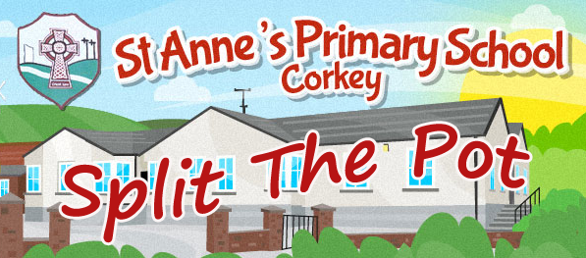

St Anne’s PTA needs your support!

Did you know that since the beginning of the school year, St Anne’s PTA has raised over £2750 through our weekly fundraiser, Split the Pot? Split the Pot is our main source of income and it is made possible entirely through the generous support of parents, families and the local community.

Every penny the PTA raises goes towards providing for pupils at St Anne’s Primary School. In the past year, the PTA has paid for:

- Bus to the annual Christmas pantomime, reducing the cost per child
- Halloween disco and raffle
- Gifts to mark the occasion for pupils making their First Holy Communion and Confirmation (personalised card and cupcake)
- Easter treats
- Sports Day refreshments
- Leavers tops/hoodies
- Gifts for new P1s (book, certificate)

Over the past few years, the PTA has also secured funding for new outdoor play equipment and new audio equipment for the school, along with funding for daily breaktime toast.

Each entry to the Split the Pot draw costs just £1, or you can purchase a ‘bulk buy’ envelope for £10 giving you 10 week’s worth of entries.
Envelopes are sent home with the children every week; you can also get them from PTA members, at the school, and at local shops.

The numbers entering Split the Pot have dropped in recent months, so please consider supporting - or continuing to support - this worthwhile fundraiser for the benefit of all the children at St Anne’s.

Could you help?

The PTA is urgently seeking new members to continue the good work for all pupils and the school community. Any and all help is appreciated, and there is no minimum time commitment. If you think you could lend a hand, please get in touch with Principal, Mr Henry Duffin at hduffin422@c2kni.net

