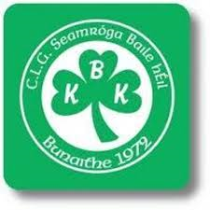
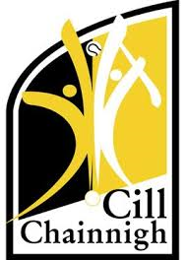
TJ Reid - The Cats!

TJ Reid was born 16th November 1987. He was born in Kilkenny. He is 1. 83 m tall which is a lot taller than me. I am 1.29 metres tall. TJ Reid is 32 years old.
TJ Reid’s mammy is called Mary. She died four years before Loughgiel won their second All Ireland.
His daddy is called Sean and thankfully he is still alive.
His daddy has beef and dairy cows. Like me, TJ likes to help his daddy on the farm. Dairy cows are the ones you milk morning and night. Beef cows are the cows that are killed for meat.
One of TJs’ heifers won a prize in the Roscrea show.
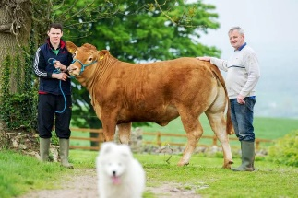
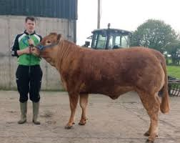
TJ Reid went to St Kieran’s college and went to university in Waterford. I wonder is that why he wears a blue and white helmet.
TJ Reid as 3 brothers’ Ritchie, Eoin and Patrick. They all played hurling for Ballyhale.
TJ Reid started to play for the under 21s hurling when he was 16. He has won 7 All Irelands for Kilkenny and 5 for Ballyhale Shamrocks. He plays number 11 for centre half forward. He as 4 All Stars. An All Star is when 15 of Ireland’s best hurlers get picked and given a trophy and a special t shirt.
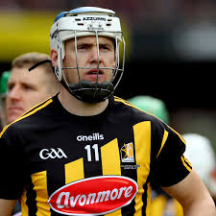
Ballyhale Shamrocks beat Slaughtneil in the semi-final this year. I watched it on the television. They beat Borrisileigh from Tipperary. The final score was 18 to 15 when they won this year’s All Ireland Club Final.
I chose TJ Reid for my project because I like hurling and he is a great player. I love farming and I found out that he likes farming too. Some day I want to be as good as TJ Reid.
By Danny McMullan
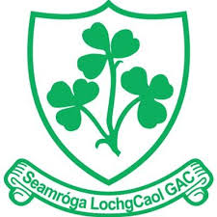
Loughgiel Shamrocks.

