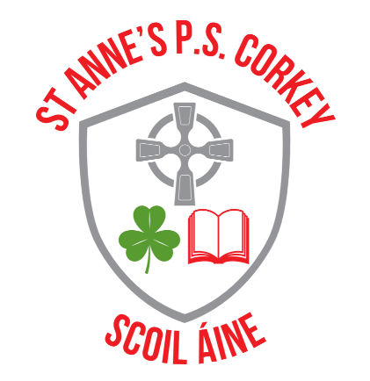
St. Anne’s Primary School
3 Reservoir Road
Corkey
Ballymena
BT44 9JE
Telephone No: 028 276 41429
Fax: 028 276 41785
hduffin422@c2kni.net
www.stannespscorkey.com
Principal: Mr. H. Duffin B.Ed. (Hons), PQH
Thursday 5th February 2026
Dear Parents and Guardians,
SUBJECT: EXPLORING THE SAFE AND RESPONSIBLE USE OF AI – SAFER INTERNET DAY 2026
This week, our school joined others nationwide to celebrate Safer Internet Day 2026, the largest global online safety campaign. This year's theme, ‘Smart tech, safe choices – Exploring the safe and responsible use of AI,’ focuses on teaching children and young people the skills to use AI technology safely and responsibly, and highlights available support.
From voice assistants, to chatbots, to algorithms, AI technology is playing an increasingly large role in all our lives. It is important that we find time to discuss these tools and the impact they can have on our own and our families’ online experiences, including:
- the news and content we see
- the way we work, including using AI for homework or studies
- the risk of misuse of AI, for example to create realistic scams or non-consensual nude images
As Safer Internet Day 2026 falls during half term, we encourage you to join us in celebrating by continuing the conversation about AI technology at home.

You may like to use one of these prompts to start a conversation with your child:
- What’s your favourite thing to do online?
- Have you ever used an AI tool? How did it make you feel?
- What do you like about AI technology?
- Do you have any worries about AI technology?
- What advice would you give to your friends about using AI?
- Who would you talk to if you saw something worrying online?
- What more can I do to help you feel safe online?

A key part of protecting children and young people from online harms is through preventative education. By talking about this in school and at home, we can all work towards keeping children safe when they are online. Celebrating Safer Internet Day is a great opportunity for you to re-emphasise the online safety messages we deliver throughout the year.
If you have any concerns or questions about keeping your child safe online, please do get in touch with myself, your child’s class teacher or Mrs McQuaid our Designated Safeguarding Teacher.

Kind regards,

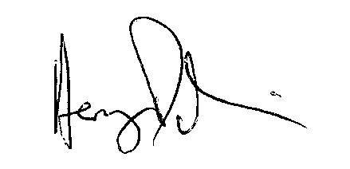
Henry Duffin (Principal)
Mrs McQuaid

