SCHOOL MILK

From: Monday 12th September – Thursday 27th October

Please complete the slip below and return to school on or before Tuesday 6th September.

If you wish your child/children to have school milk the cost will be £6.80 per child which must be paid at time of ordering. Due to limited change we would ask parents to send the correct money if possible. Sorry no later orders will be accepted.

Many thanks
------------------------------------------------------------------------------------------

Name of Child/Children --------------------------------------------------
--------------------------------------------------
--------------------------------------------------

I wish my child to have school milk and enclose payment of £6.80 per child.
I do not wish my child to have school milk.
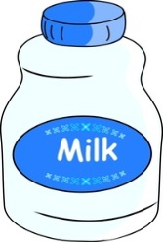
Please tick appropriate box

Signed ----------------------------------------------------

