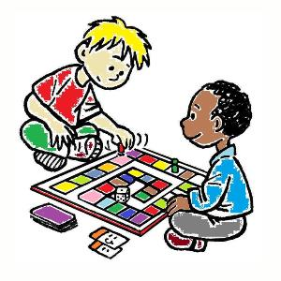
Creative and Board Games After Schools Club

St Anne’s teachers would like to offer children from P4 to P7 the opportunity to join our Creative or Board Games After Schools Club. The club will be on Thursdays beginning on 4th February. The club will run from 2.50 pm to 4.00 pm.

If you would like your child to join either club, please complete the reply slip below and return to your child’s teacher by Tuesday 2nd February.

The cost of these clubs is £2 per child or £3 per family. If either club is oversubscribed we will draft a timetable to ensure everyone has the opportunity to take part.

Thank you for your support

Mr Henry Duffin

St Anne’s Primary School

I would like my child/children to join the following St Anne’s After Schools Club:

Creative Club Name of Child/Children _______________________
_______________________

Board Games Club Name of Child/Children _______________________
_______________________

Signed: _______________________________________ (parent/guardian

Date: _________________________________________

