St Anne’s Primary School
After Schools Cultural Club
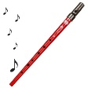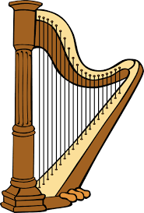

Our After Schools Cultural Club for P4 to P7 pupils will begin on Wednesday 11th September with Mrs Marie Kinney, and will continue every week until the 23rd October (7 Weeks). The children will be learning Irish, playing the tin whistle and taking part in traditional Irish dancing.
The club will commence from 3.00-4.00pm, therefore parents will have to arrange to collect their child/children at this time.
Where more than 20 pupils apply, we will select pupils for the first rotation and ensure that those who missed out will be on the next rotation.
Please return the reply slip below as soon as possible, along with the fee for £7.
Thank you for your continued support.
H Duffin
Principal

After Schools Cultural Club
Child/Children’s Name: __________________________________________
__________________________________________
__________________________________________

I would like my child to attend the After Schools Cultural Club and enclose payment below.
1 Child £7
Family of 2 £14
Family of 3 £21

Signed: ________________________________________ Parent/Guardian

