St Anne’s Primary School
After Schools Hurling /Camogie Club
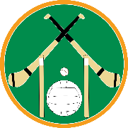
Our After Schools Hurling / Camogie Club for P4 to P7 pupils will begin on Monday 11th November with Miss Lynn and Mr Duffin, and will continue every week until 2nd December (4 weeks). Because the last club was cancelled on 24th October, the children will have 1 week owed to them.
The club will commence from 3.00-4.00pm. The children will be outside, weather permitting, otherwise the club will take place in the hall. Suitable clothing and footwear should be worn.
Please return the reply slip below as soon as possible, along with the fee of £3.
Thank you for your continued support.
H Duffin
Principal

After Schools Hurling/Camogie Club

Child/Children’s Name: __________________________________________
__________________________________________

I would like my child to attend the After Schools Hurling/Camogie Club and enclose payment below.
1 Child £3
Family of 2 £6

Signed: ________________________________________ Parent/Guardian

